TREASURY REGISTER DOCUMENT 4 OF 4
Architecture
Context, containers, components, integration, failure behaviour and fourteen decision records.
Documents 1 to 3 describe what the system holds, what it exposes and what it looks like. This one describes how it is put together, what it depends on, how it behaves when a dependency fails, and which decisions would be expensive to reverse.
Stack: Next.js, FastAPI, SQLAlchemy 2.0, SQLite, with PostgreSQL as the stated destination.
Companion documents: 1, data model. 2, application programming interface. 3, user interface.

1. The shape of the system, in one page
Statement | Consequence
It is one system, not four modules | Counterparty control, dealing, advisory and currency risk share one database and one deal record. There is nothing to integrate between them because there is no gap to cross. The only real integration on this project is with Oracle, which is a separate product with a separate database.
It is a control system, not a register | A register stores what happened. This decides whether a thing is allowed to happen and keeps testing that decision as the world changes. Everything in the architecture serves that difference, and the rule engine is where it lives.
It holds no cash and moves no money | Oracle pays, Oracle holds the ledger, dealing portals execute. The platform describes what should happen and hands over. This is what keeps the integration surface small and the existing payment controls untouched.
The model proposes and never decides | The advisory layer writes no deals. Its only path into the book runs through a person and then through the same six checks as anything typed.
Every threshold is data | No limit, cap, band or target is coded. All of it comes from versioned policy tables that a customer owns.

2. Context
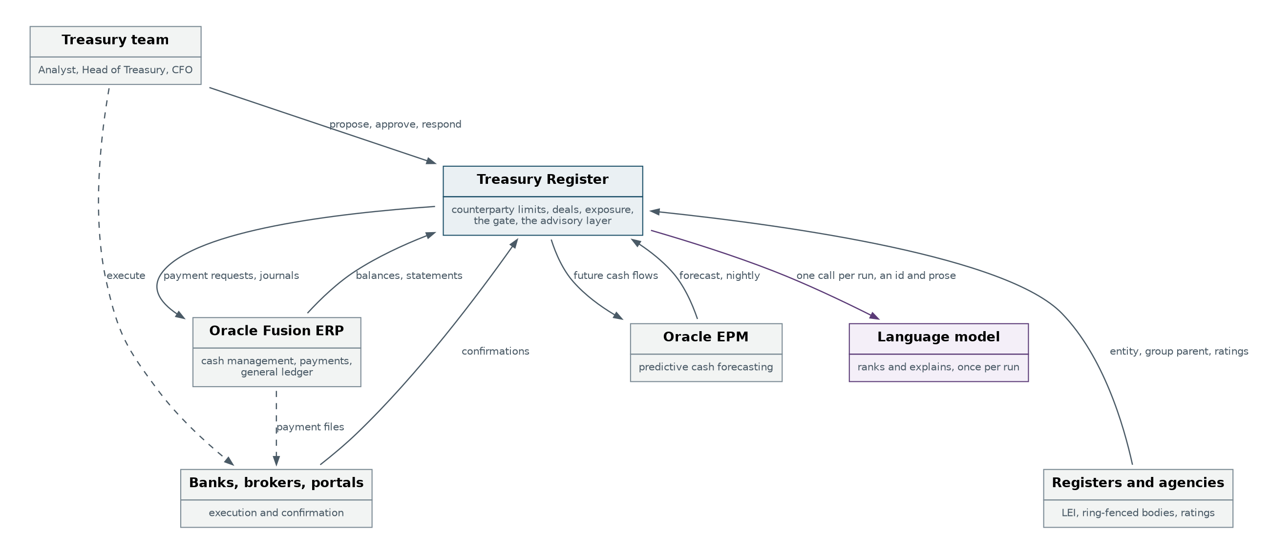
Figure 1. The system and everything it talks to.
Actor or system | Relationship | Owned by
Treasury team | Proposes deals, approves counterparties and limits, responds to breaches, accepts or rejects recommendations. Five touch points in the whole platform. Everything else is unattended. | Customer
Oracle Fusion | Supplies balances and statements. Receives payment requests and journals. Decides nothing. | Customer
Oracle EPM | Supplies the forecast the advisory layer tests against. Receives future cash flows so tomorrow's forecast includes today's deals. | Customer
Banks, brokers, portals | Execute. Send confirmations, which arrive on a separate route from the deal details on purpose. | Third party
Registers and agencies | Legal entity identifier, ring-fenced bodies list, credit ratings. The group parent comes from here, and it is the field the whole group check rests on. | Third party
Language model | Called once per advisory run. Returns a candidate identifier and prose. Never a number. | Third party

3. Containers
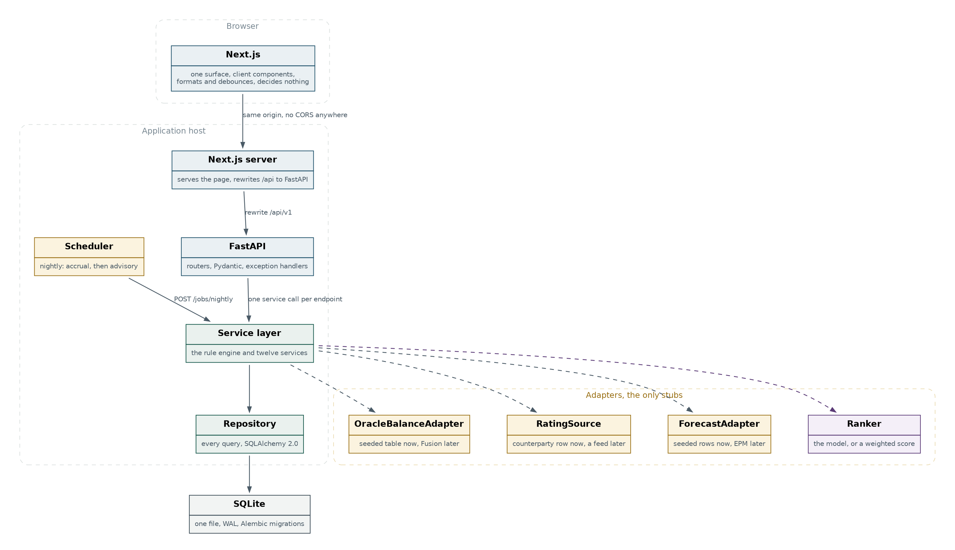
Figure 2. What runs where, and the four adapters that are the only stubs.
Container | Technology | Responsibility | Explicitly not
Browser application | Next.js, client components | One surface. Formats, lays out, debounces, cancels in flight requests. | Any rule. No check logic, no limit arithmetic, no approval threshold, no candidate filtering.
Web server | Next.js server | Serves the page and rewrites /api to FastAPI, so the browser only ever sees one origin. | Business logic. No server actions, no route handlers holding rules.
Application programming interface | FastAPI | Routing, Pydantic validation, serialisation, exception handling. | Rules. A router validates, calls one service, returns.
Service layer | Plain Python | The rule engine and twelve services. Every decision in the system. | SQL.
Repository | SQLAlchemy 2.0 | Every query. | Rules or arithmetic.
Storage | SQLite, WAL, Alembic | One file. Migrations from day one. | Anything computed, except the stored accrual.
Scheduler | Cron or an equivalent | Calls the nightly job. Accrual, then advisory. | Any logic of its own. It is a caller, not a component.
Two processes, not one, and they run on the same host. Wrapping them in one start script matters more than it sounds, because on the day of a demonstration two terminals is one more thing to go wrong.

4. Components
Thirteen services. The dotted lines are calls to the repository, which every service makes. The solid lines are the only calls services make to each other, and there are six of them.
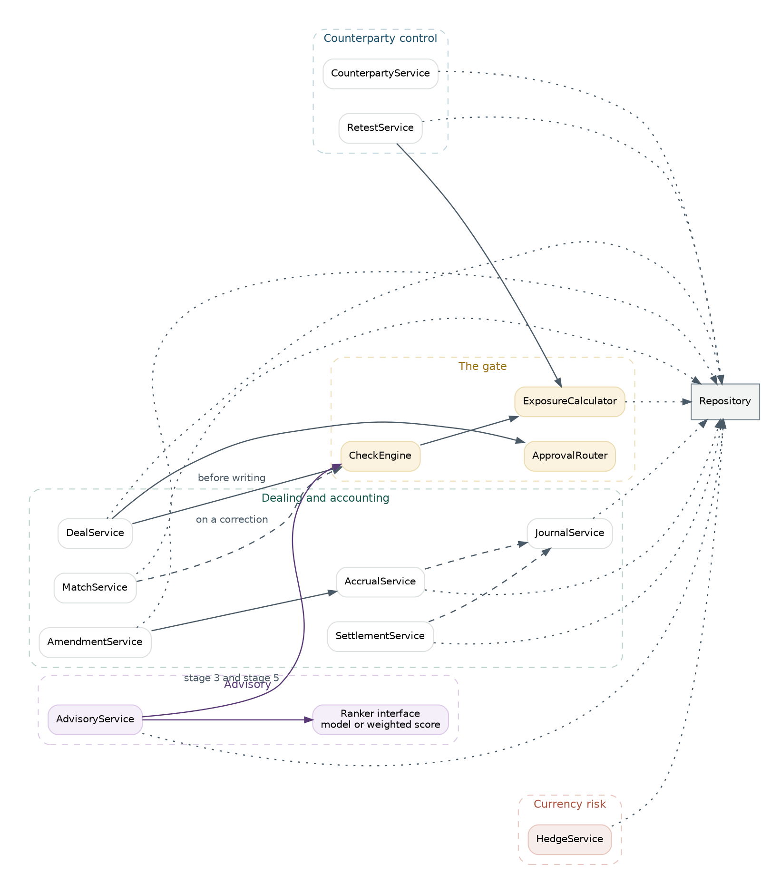
Figure 3. The service layer. Note how few arrows cross a boundary.
Rule | Detail
A router calls exactly one service | Anything longer than about ten lines in a router belongs in a service. This is the rule that stops the API layer accreting logic.
Services reach data only through the repository | No service constructs a query. This is what makes the move to PostgreSQL a dialect change rather than an audit of every file.
Cross service calls are enumerated, not free | Six exist. DealService and MatchService call CheckEngine before writing. AdvisoryService calls it twice, at stage 3 to build a compliant candidate list and at stage 5 to validate. AmendmentService calls AccrualService. DealService calls ApprovalRouter. Anything else is a design change to argue about.
The gate is one component | CheckEngine, with ExposureCalculator underneath it. Every path into the book passes through it, whether a person typed the deal, a model proposed it, or a correction changed it.
The model sits behind an interface | AdvisoryService depends on a Ranker with two implementations. Switching model_enabled off swaps the implementation and nothing else in the code path changes.

5. The rule engine
The single most important structural decision in the system, restated here because everything else depends on it.
Browser --POST /deals/check--> CheckEngine writes nothing
Browser --POST /deals-------> DealService
|
+--> CheckEngine the control
+--> write check_run
+--> write deal or block it

AdvisoryService --stage 3--> CheckEngine exclude before ranking
--stage 5--> CheckEngine validate after ranking

MatchService --correction--> CheckEngine a new rate changes exposure

Property | Why it holds
One implementation | There is one CheckEngine. The browser has no copy, the advisory layer has no copy, and the matching service has no copy.
Called twice on every booking | Once for the user, once as the control. The create endpoint has no field for a client supplied result, so it cannot accept one.
Reproducible | Every run records the limit version, the policy version, the as of date and the inputs. A decision from six months ago can be re-derived rather than reconstructed.
Fails closed | A check that cannot read its inputs fails rather than passes. The concentration check with no Oracle balance is the worked example.
Between the user's last keystroke and their submit, another user can book a deal, a rating can move, or the clock can change. In each case the browser holds a result that is now wrong. Running the checks again on the server is the only defence, and it costs one query.

6. The advisory layer as a component
Six stages, one of which calls a model. The other five exist so that the one which does cannot go wrong.
Stage | Kind | What it guarantees
1 Assemble context | Deterministic | Built by query from data already owned. There is no retrieval quality problem because nothing is retrieved.
2 Detect the gap | Deterministic | Arithmetic against the investment policy. With no gap the model is never called at all.
3 Build candidates | Deterministic | The main guardrail. Anything that would fail the six checks is excluded before the list exists, and the exclusion is recorded with its reason.
4 Rank and explain | The model | Output constrained to a candidate identifier and prose. It never generates a number.
5 Validate | Deterministic | Three tests: the identifier is real, the six checks rerun clean, and every figure in the prose matches a value computed at stage 3.
5b Rule based pick | Fallback | A weighted score of yield, headroom impact and ladder fit. Flagged as such. The feature degrades rather than failing.
6 Accept or edit | Human | Records a decision and returns a ticket. Books nothing.

6.1 Why hallucination is structurally impossible
Failure it cannot produce | Because
An invented counterparty | The recommendation carries a foreign key to a candidate row that the rules created. There is no free text field for a name.
An invented rate or amount | Every figure was computed at stage 3 and re-checked at stage 5. The model has no arithmetic to do.
A recommendation against policy | Non compliant options were never in the list it saw.
A confident wrong answer | Validation rejects it, the deterministic pick is shown instead, and the source field says RULE_FALLBACK on screen.
The ability is removed rather than instructed against. No prompt says do not invent counterparties. The design makes it impossible, and that is the difference between a guardrail and a hope.
Worth knowing internally: with four candidates and a clear priority order, a scoring formula ranks them much the same. The model's real contribution is the explanation, which is hard to write as a rule. The AI framing should not be oversold on the ranking.

7. Integration surface
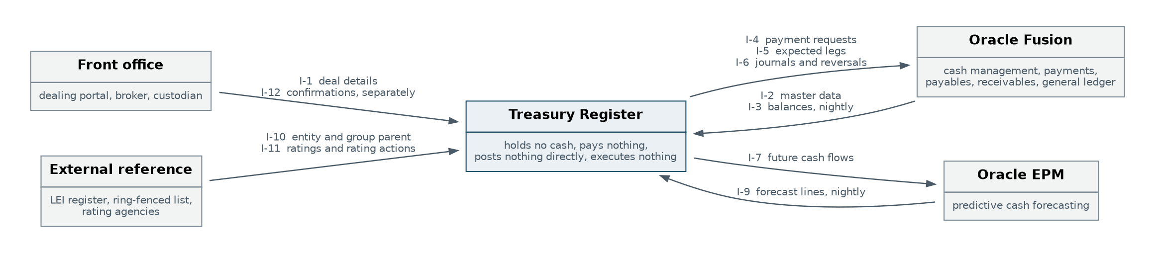
Figure 4. Twelve interfaces. Four of them are new in this design.
Reference | Direction | Payload and trigger | This build
I-1 | Front office to platform | Deal details, on execution | Keyed
I-2 | Fusion to platform | Master data and rates, periodic | Seeded
I-3 | Fusion to platform | Balances and positions, nightly | Adapter over a seeded table
I-4 | Platform to Fusion | Payment request, on approval | Written to a table, not sent
I-5 | Platform to Fusion | Expected inbound leg, on booking | Not built
I-6 | Platform to Fusion | Journals and reversals, daily or monthly | Built, not posted
I-7 | Platform to EPM | Future cash flows, nightly | Not built
I-9 | EPM to platform | Forecast lines, nightly | Adapter over seeded rows
I-10 | External to platform | Entity and group parent, on add | Entered by hand. Free from the public register
I-11 | External to platform | Ratings and rating actions, daily | Adapter over the counterparty row
I-12 | Front office to platform | Confirmations, on confirmation | Endpoint exists, no feed
I-12 is kept separate from I-1 deliberately. They could be one interface, but matching only works because the two records arrive independently. Fold the confirmation into the deal feed and there is nothing to match against, so the control disappears.
Cross cutting | Decision
Identity | Entra ID single sign on across all three systems. Not built. Section 10.
Authorisation on interfaces | OAuth2 client credentials on every machine to machine call.
Residency | Oracle UK regions.
Method | Deliberately unspecified. The integration layer is a separate decision and the adapters make it a late one.

8. Failure behaviour
What still works when each dependency is unavailable. This is the table to have answered before somebody asks it in a room.
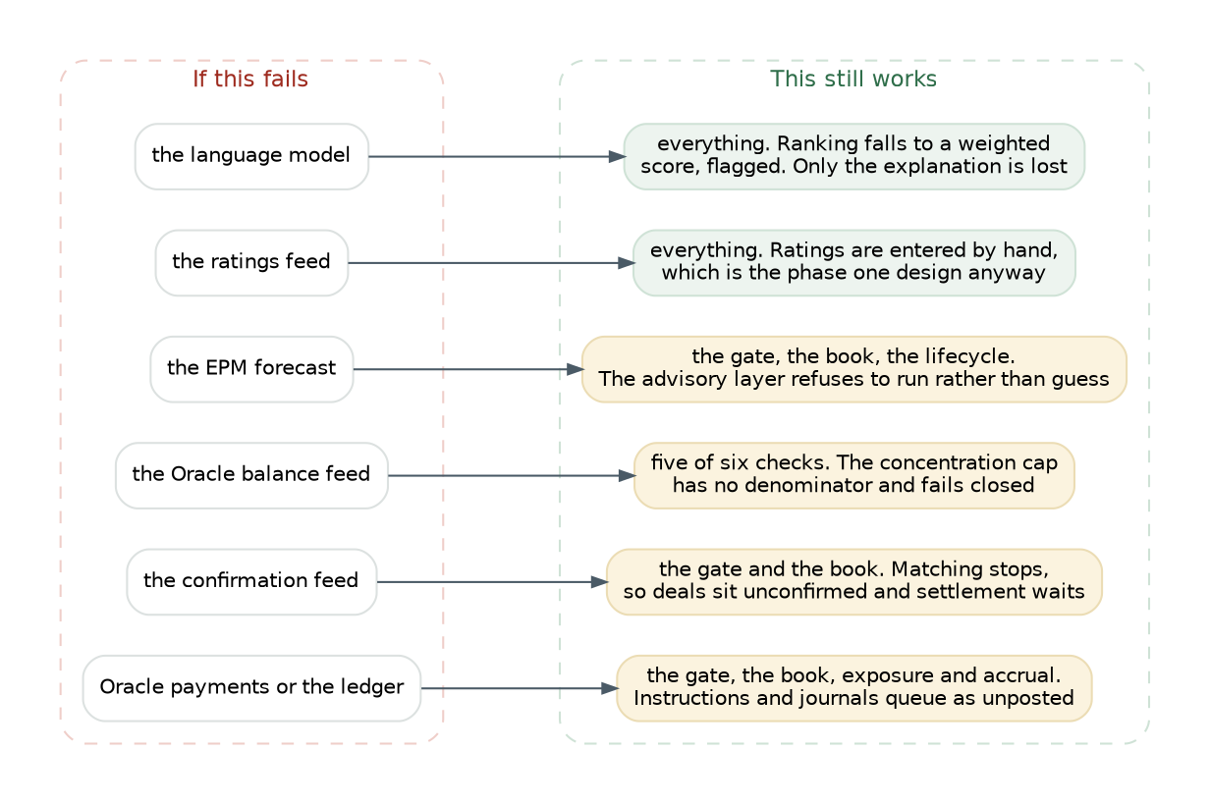
Figure 5. Degradation, dependency by dependency.
Dependency | Behaviour | Design choice behind it
The language model | Ranking falls to the weighted score. The recommendation survives, flagged as RULE_FALLBACK. Only the explanation is lost. | The Ranker interface, and computing score_bp on every candidate whether or not the model runs.
The ratings feed | Ratings are entered by hand, which is the phase one design anyway. | RatingSource behind an interface.
The EPM forecast | The advisory layer refuses to run and says why. Everything else is unaffected. | Refusing rather than guessing. A gap measured against a stale forecast is worse than no recommendation.
The Oracle balance feed | Five of six checks still run. The concentration check has no denominator and fails closed, which blocks deals. | Failing closed is correct for a control. It is also the single most disruptive failure in the system, and section 11 lists it as a risk.
The confirmation feed | The gate and the book are unaffected. Matching stops, deals sit unconfirmed, and settlement waits. | Confirmation is a separate table with its own arrival path.
Oracle payments or the ledger | The gate, the book, exposure and accrual all continue. Instructions and journals accumulate as unposted. | The platform describes what should happen and hands over. Nothing depends on the handover succeeding.
The database | Nothing works. There is one file and no replica. | Accepted for a prototype. Section 9.3 covers what changes.

9. Non functional behaviour

9.1 Performance budget
Path | Budget | Why that number
POST /deals/check | Under 80 milliseconds at the ninety-fifth percentile | It runs on every pause in typing. Above about 150 milliseconds the panel stops feeling live, and the whole demonstration rests on it feeling live.
GET /state | Under 300 milliseconds | Once on load and once after every write. It is the largest response in the system.
GET /deals/{id} | Under 200 milliseconds | One click, one panel, one call.
POST /jobs/nightly | No budget | Nobody is waiting. It returns 202 and runs.
The check path is the only one with a tight budget, and it is met by two indexes rather than by caching. Exposure is recomputed on every call by design, and at prototype volume the query reads tens of rows.

9.2 Concurrency
Concern | Position
Endpoints are synchronous | The SQLite driver blocks. FastAPI runs synchronous endpoints in a threadpool, which is correct here. An async endpoint doing blocking work would stall the event loop, and the calls it would stall are the keystroke checks.
WAL mode, set on connect | Without it a read blocks a write, and the nightly job would freeze the interface.
One session per request | A FastAPI dependency yields and closes it. A session shared across threads is a defect, not a risk.
One writer at a time | A SQLite property, not a defect. Invisible at one user. The first thing to change at two.
The nightly job | Holds a write transaction for as long as the accrual takes. Under a second at prototype volume. At real volume the accrual commits per deal instead.

9.3 Sizing and the scaling path
Dimension | Now | Next | The trigger to move
Storage | SQLite, one file | PostgreSQL | A second concurrent writer, or a backup requirement. Not a row count.
Tenancy | A column with one value | The same column plus row level security | A second customer. The column already exists so this is a policy addition, not a migration.
Deployment | Two processes on one host | Two containers behind one ingress | Anyone using it who is not in the room.
Volume | Tens of deals, hundreds of accruals | Thousands of deals, millions of accruals | Accrual is the table that grows daily. It is the first to need partitioning by period.
Exposure | Recomputed on every read | Recomputed, with a materialised projection and a rebuild guarantee | When the check path breaches its budget. Not before, because a cached figure that drifts from the deals is worse than a slow query.
Concurrency model | Synchronous on a threadpool | Unchanged | Moving to async only pays once the driver is non blocking, which means after PostgreSQL, not before.
The order matters. PostgreSQL first, then row level security, then containers. Reversing it means running multi tenant isolation on a single file database, which is the one combination with no good answer.

10. Identity, and the largest gap
There is no authentication. Every actor in the system is a string in a request body. This is stated plainly because it is the largest single gap in the design, and because the other three documents each reach the same conclusion from a different direction.
What is missing | What it prevents today
A user table and sign in | Nothing distinguishes one caller from another.
Roles | The approval router names the role a deal requires and nothing checks that the caller holds it.
Segregation of duties | The proposer can approve their own deal. With the advisory layer added, the same person can accept a recommendation and then approve the deal it produced, which is the same hole twice.
An audit subject | Every evidence record names a person as free text. The check run, the limit approval and the override reason are all only as good as what somebody typed.
The work to close it is small and the order is fixed. A user table and a membership table with a role. A bearer token, with the actor taken from the token and never from the body. One comparison in ApprovalRouter. One constraint that the approver is not the proposer. Everything else already exists, because every service already records who acted.
This is deliberately not built in the prototype. It adds a sign in screen to a demonstration that has none, and it protects nothing while the only user is the person presenting. It is the first thing to add before anyone else touches the system.

11. Decision records
Fourteen decisions that would be expensive to reverse. Each records what was decided, what it costs, and what would make it worth revisiting.

ADR 01 One system, not four modules
Context | The process design describes five models, which reads as five systems that need integrating.
Decision | One database, one deal record, one exposure figure. The models are subject areas, not services.
Consequence | Nothing passes between them because there is no gap to cross. A deal cannot exist without a counterparty, and a counterparty's exposure cannot be known without deals, so the dependency is circular and separating them would be awkward rather than merely inelegant.
Revisit if | One subject area needs to scale independently of the others. None does today.

ADR 02 The rule engine runs on the server, with two callers
Context | The interface needs a live result on every keystroke, and the system needs a trustworthy decision at the moment of writing.
Decision | One engine, two endpoints. The check endpoint writes nothing. The create endpoint re-runs the same engine and has no field for a client supplied result.
Consequence | One extra evaluation per booking, which costs a query. In exchange the control cannot be bypassed by a stale browser.
Revisit if | Never. This is the decision the product rests on.

ADR 03 Money as integer minor units, never floating point
Context | Limit checks compare sums of money to thresholds.
Decision | Sterling as integer pence with the suffix _pence. Other currencies as integer minor units with the suffix _minor and a mandatory currency field.
Consequence | Every display formats. Every calculation is exact. An accidental addition of euros to pence is visible in the code rather than only in the result.
Revisit if | Never.

ADR 04 Exposure computed, accrual stored
Context | Both are derived from deals. Only one is safe to recompute.
Decision | Exposure is computed on every read. Accrual is written once per deal per day and never recomputed.
Consequence | Exposure cannot drift from the deals behind it. Accrual cannot be quietly rewritten by a later recalculation, which is what makes amendments and reversals possible at all.
Revisit if | The check path breaches its budget. The answer is a rebuildable projection, not a stored figure.

ADR 05 Limits and policies are versioned, never edited
Context | An auditor asks what the limit was on the day of a deal, and what rule produced it.
Decision | Superseded rows rather than overwritten fields, for both the limit and the treasury policy. A partial unique index enforces one current version of each.
Consequence | Every historic decision is re-derivable. The cost is one index and a slightly longer write path.
Revisit if | Never.

ADR 06 SQLite now, PostgreSQL later, through SQLAlchemy
Context | A prototype needs zero setup. A product needs concurrency and backups.
Decision | SQLAlchemy 2.0 with Alembic from the first commit, over SQLite. Not raw sqlite3.
Consequence | The move becomes a dialect change rather than a rewrite of every query. Limits, policy and rating bands will change shape more than once, and migrations are what that needs.
Revisit if | A second concurrent writer appears, which is the trigger to move rather than a reason to reconsider the approach.

ADR 07 Synchronous endpoints on a blocking driver
Context | FastAPI invites async. The SQLite driver blocks.
Decision | Endpoints are def, not async def, and run in FastAPI's threadpool.
Consequence | Correct behaviour under load. An async endpoint doing blocking work would stall the event loop for every other request, and the requests it would stall are the keystroke checks.
Revisit if | The driver becomes non blocking, which means after PostgreSQL and an async driver, not before.

ADR 08 Next.js is the view layer and nothing else
Context | Next.js can hold logic in server actions and route handlers.
Decision | It does not. It serves the page, rewrites /api to FastAPI, and renders. No server actions, no data fetching in server components, no rules.
Consequence | There is exactly one rule engine. Same origin, so no cross origin configuration exists anywhere and there is one URL to open.
Revisit if | Never, while the rule engine matters.

ADR 09 Adapters for every external dependency, from day one
Context | Four dependencies are stubbed: balances, ratings, the forecast, and the model.
Decision | Each sits behind an interface defined before its stub is written.
Consequence | Replacing a stub is a swap, not a rewrite. It costs nothing now and is the difference between a prototype that grows and one that gets thrown away. It is also what makes the integration method a late decision.
Revisit if | Never.

ADR 10 The candidate list is built by rules, before the model sees anything
Context | A model that can name a counterparty can name the wrong one.
Decision | Stage 3 builds a bounded, priced, already compliant list. The model returns an identifier from it and prose. It never generates a number.
Consequence | Hallucination is removed rather than instructed against. The cost is that the model cannot propose anything creative, which is the correct trade for money that is not ours.
Revisit if | Never, for this domain.

ADR 11 The model can be switched off, and degrades rather than fails
Context | A model call can be slow, unavailable, or produce output that fails validation.
Decision | A Ranker interface with two implementations. score_bp is computed on every candidate whether or not the model runs.
Consequence | The recommendation always exists. Only the explanation is lost, and the interface says so. model_enabled is a policy field, not an environment variable, so a customer owns it.
Revisit if | Never.

ADR 12 A tenant column on every operational table from day one
Context | One customer today, a product tomorrow.
Decision | tenant_id on every operational table, one seeded value, never queried differently.
Consequence | Free now. A migration across thirty-three tables later. The destination is the same column plus row level security in PostgreSQL, which is a policy addition rather than a schema change.
Revisit if | Never.

ADR 13 One state endpoint for a single surface
Context | The surface needs eleven collections to render.
Decision | GET /state returns all of them from one transaction.
Consequence | No waterfall, no eleven loading states, and every figure on screen agrees with every other because they came from one read. The cost is the largest response in the system, and it is the first thing to break apart when a second screen exists.
Revisit if | A second screen appears, or the response exceeds a few hundred kilobytes.

ADR 14 The two exposures are never joined
Context | Counterparty exposure and currency exposure share a word and move in opposite directions. A forward increases the first and reduces the second.
Decision | Different tables, different units, different endpoints, no shared key. currency_exposure deliberately has no counterparty_id.
Consequence | A combined figure cannot be asked for, which is cheaper than documenting that it should not be. The cost is two endpoints where a reader might expect one.
Revisit if | Never. Someone will eventually try to net them, and the model has to be the thing that stops them.

12. Risks and open decisions

12.1 Risks
Risk | Effect | Mitigation
No identity | No segregation of duties, and every audit record is free text. | Section 10. Small work, fixed order, first thing after the prototype.
The concentration check depends on Oracle | Losing the balance feed fails the check closed, which blocks every deal. | Correct for a control, disruptive in practice. The mitigation is an explicit stale threshold and a visible warning rather than a silent failure.
Accrual volume | It grows daily per live deal and is the first table to become large. | Partition by period once it matters. Nothing else in the design depends on scanning it.
Amendments touching closed periods | An accounting policy question with no technical answer. | Surfaced as a distinct refusal rather than decided in code. Needs settling with the customer's accountants.
The advisory layer needs a policy that may not exist | Without a buffer, a ladder and cover targets there is nothing to measure a gap against. | The layer refuses to run and says so. This is also an opportunity to shape the policy rather than a pure blocker.
One database file, no replica | Total loss on corruption. | Accepted for a prototype. Closed by the move to PostgreSQL rather than by anything before it.

12.2 Decisions still open
Decision | Why it changes the build | Recommendation
Hard block or warn with an override | Determines the whole exception workflow. | Ship both as a policy setting. Settle it by flipping it on a failing deal in the room, not in a slide.
Prior period corrections | Determines how reversals work. | Surface as a refusal, decide with the accountants.
Keyed then matched, or created from the confirmation | Two different builds. Both are supported by capture_source. | Support both, default to keyed, because the confirmation feed is the last thing to arrive.
Confirmation coverage | Which counterparties send machine readable confirmations and which send a document. | Needs the customer. Manual handling is a different design.
Journal posting frequency | Daily calculation is required either way. Daily, weekly or monthly posting is a volume and reconciliation decision. | Daily, unless the customer's close process says otherwise.
Hedge accounting under IFRS 9 | The difference between a modest build and a specialist one. | Recommended out. Needs confirming rather than assuming, and there is an accounting question about whether the movement is capitalised into the asset cost instead.
Multi currency deposits | The limit arithmetic assumes one currency. | Out of scope until a customer holds a deposit in euro. The currency column exists so the answer is a service change, not a schema change.

13. Build sequence
Step | Why in this order
1. Schema and seed | Everything else is meaningless without a populated book.
2. ExposureCalculator | The join between both sides. Wrong here means the checks are wrong too.
3. CheckEngine and the check endpoint | Testable against the seeded numbers before any screen exists.
4. The single screen | Book, ticket, live checks. This is the demonstration.
5. Deal creation and the queue | Makes the blocked path resolvable rather than a dead end.
6. RetestService and the ratings panel | The closing argument, and cheap because the rating is a field.
7. The exposure panel | Last to build, first thing a board member asks for.
8. Onboarding | Independent of the loop, so it can be built alongside.
9. Accrual and journals | Phase two. Nothing before this needs stored accrual.
10. The advisory harness | Phase two, and only after an investment policy exists.
11. Confirmation, matching, amendments, settlement | Phase three. The largest single block of work in the system.
12. Currency exposure and hedge linkage | Phase three, and the smallest of the three subject areas to add.
Steps 1 to 3 are testable with no user interface at all. Write them against the seeded numbers and assert the demonstration outcomes before anything visual exists. If those pass, the demonstration works. If they do not, no amount of front end polish saves it.

